
BEE 3202: TRANSMISSION LINES AND WAVEGUIDES
Lab 1 Report:
Simulation of Waveguide Propagation Using ANSYS HFSS
Mwongela Edward Aribu
142092

Lecturer: Dr. Shamim Omar Nassar

Contents
List of figures 3
Lab Objectives 4
Materials and Equipment 4
Procedures 5
Observations and Data 7
Analysis 14
Theoretical Background 14
Theoretical Cutoff Frequency (TE₁₀ Mode) 14
Propagation Constant (γ) 14
Skin Effect in Thin Waveguides 14
Characteristic Impedance (Z₀) 15
Group Velocity & Delay 15
Method: 15
Key Observations: 16
Discussion 16
Conclusion 17
Key findings: 17
Challenges & Recommendations: 17
Appendices 18

List of figures
Figure 1. simulation 5
Figure 2. simulation 5
Figure 3. original S-parameters plot 6
Figure 4. properties of 0.5mm by 29.6mm on 0,0,0 7
Figure 5. simulation image of 0.5mm by 29.6mm on 0,0,0 7
Figure 6. S-parameter plot of 0.5mm by 29.6mm on 0,0,0 7
Figure 7. properties of 0.5mm by 29.6mm on 0.25mm,0,0 8
Figure 8. simulation of 0.5mm by 29.6mm on 0.25mm,0,0 8
Figure 9. S-parameter plot of 0.5mm by 29.6mm on 0.25mm,0,0 8
Figure 10. properties of 1mm by 29.6mm on -MW/2 ,g ,0mm 9
Figure 11. simulation of 1mm by 29.6mm on -MW/2 ,g ,0mm 9
Figure 12. S-parameter plot of 1mm by 29.6mm on -MW/2 ,g ,0mm 9
Figure 13. properties of 1mm by 29.6mm on 0,0,0 10
Figure 14. simulation of 1mm by 29.6mm on 0,0,0 10
Figure 15. S-parameter plot of 1mm by 29.6mm on 0,0,0 10
Figure 16. properties of 1.8mm by 29.6mm on -MW/2 ,g ,0mm 11
Figure 17. simulation of 1.8mm by 29.6mm on -MW/2 ,g ,0mm 11
Figure 18. S-parameter plot of 1.8mm by 29.6mm on -MW/2 ,g ,0mm 11
Figure 19. properties of 3.6mm by 29.6mm on -MW/2 ,g ,0mm 12
Figure 20. simulation of 3.6mm by 29.6mm on -MW/2 ,g ,0mm 12
Figure 21. S-parameter plot of 3.6mm by 29.6mm on -MW/2 ,g ,0mm 12
Figure 22. properties of 3.6mm by 29.6mm on -1.8mm,0,0 13
Figure 23. simulation of 3.6mm by 29.6mm on -1.8mm,0,0 13
Figure 24. S-parameter plot of 3.6mm by 29.6mm on -1.8mm,0,0 13

Lab Objectives
- To simulate transmission lines/waveguides using ANSYS HFSS.
- To analyze S-parameters and propagation characteristics.
- Comparing theoretical results with simulated data.

Materials and Equipment
1. ANSYS HFSS software.
2. Computer with adequate specifications for simulation.
3. Reference materials (e.g., waveguide theory textbooks).
4. YouTube tutorials for `.aedt` file setup:
[HFSS Tutorial: Design of SMA Connector] (https://www.youtube.com/watch?v=xu8pRldksCg)
[HFSS Tutorial: Test-Bench for SMA Connector Verification]( https://www.youtube.com/watch?v=-cHbeGcCDc8)

Procedures
1. Software Setup:
- Install ANSYS HFSS and configure the workspace.
- Follow the linked tutorials to create `.aedt` project files.
2. Design Waveguide/Transmission Line:
- Define geometry (e.g., dimensions, material properties).
- Set up ports and boundary conditions.
3. Simulation:
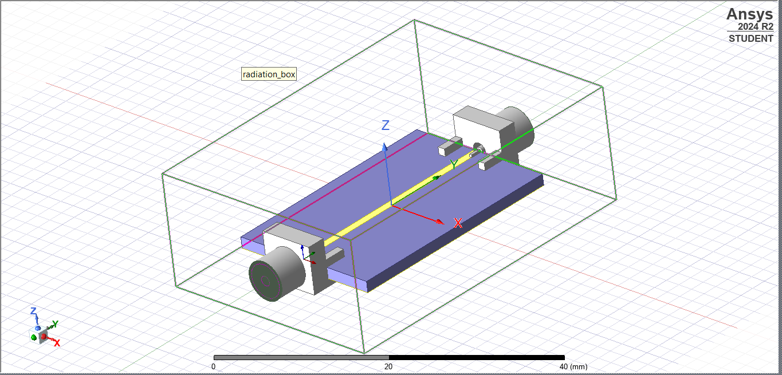
Figure 1. simulation
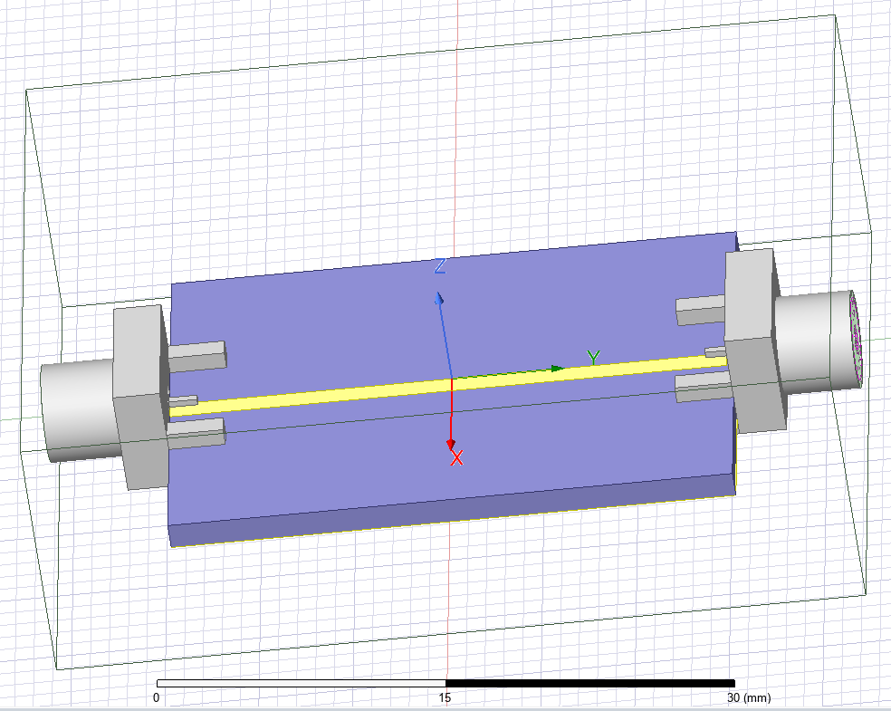
Figure 2. simulation
- Run frequency sweeps and analyze modes.
4. Data Collection:
- Export S-parameters and field plots.
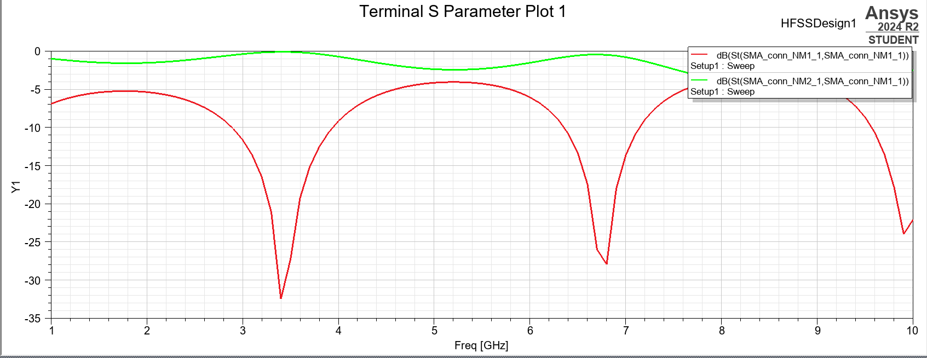
Figure 3. original S-parameters plot

Observations and Data
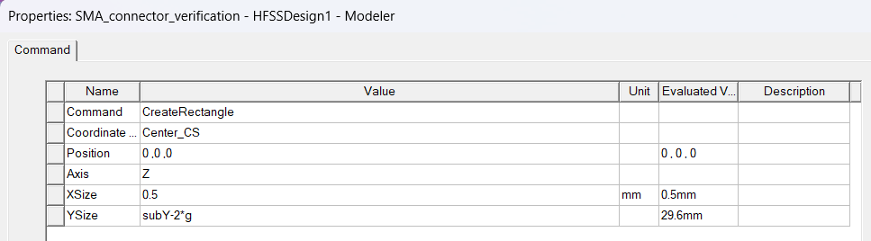
Figure 4. properties of 0.5mm by 29.6mm on 0,0,0
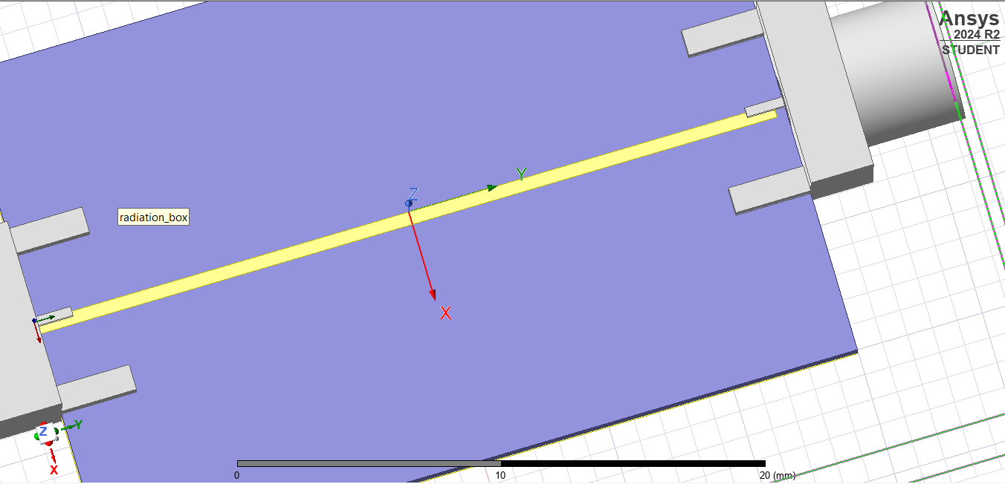
Figure 5. simulation image of 0.5mm by 29.6mm on 0,0,0
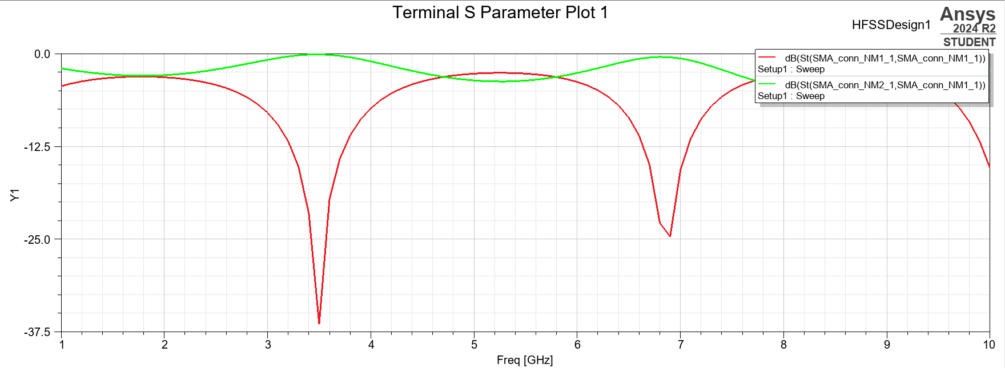
Figure 6. S-parameter plot of 0.5mm by 29.6mm on 0,0,0
0.5mm by 29.6mm on 0,0,0
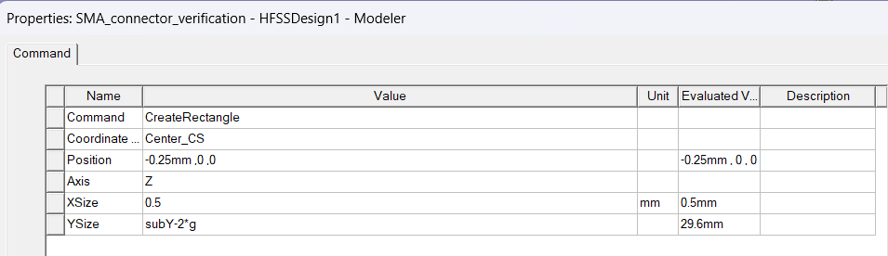
Figure 7. properties of 0.5mm by 29.6mm on 0.25mm,0,0
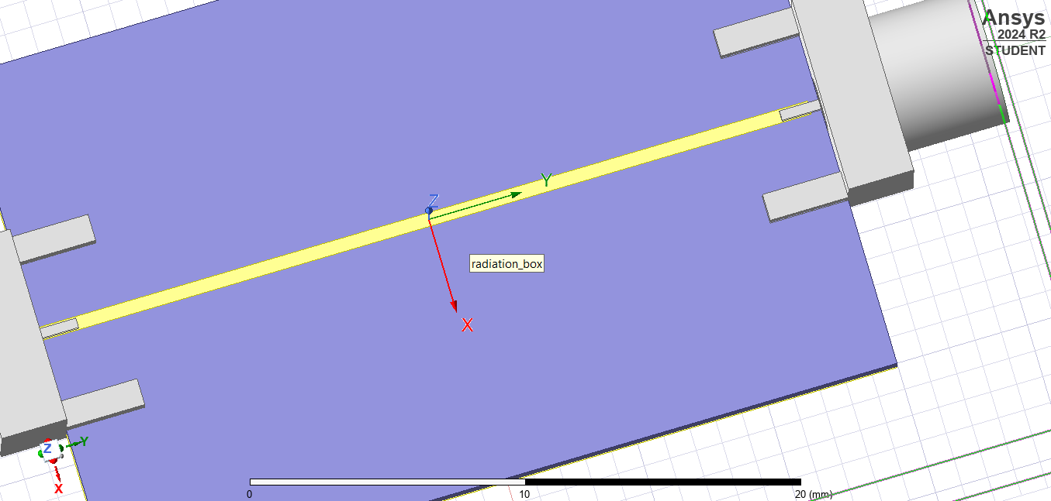
Figure 8. simulation of 0.5mm by 29.6mm on 0.25mm,0,0
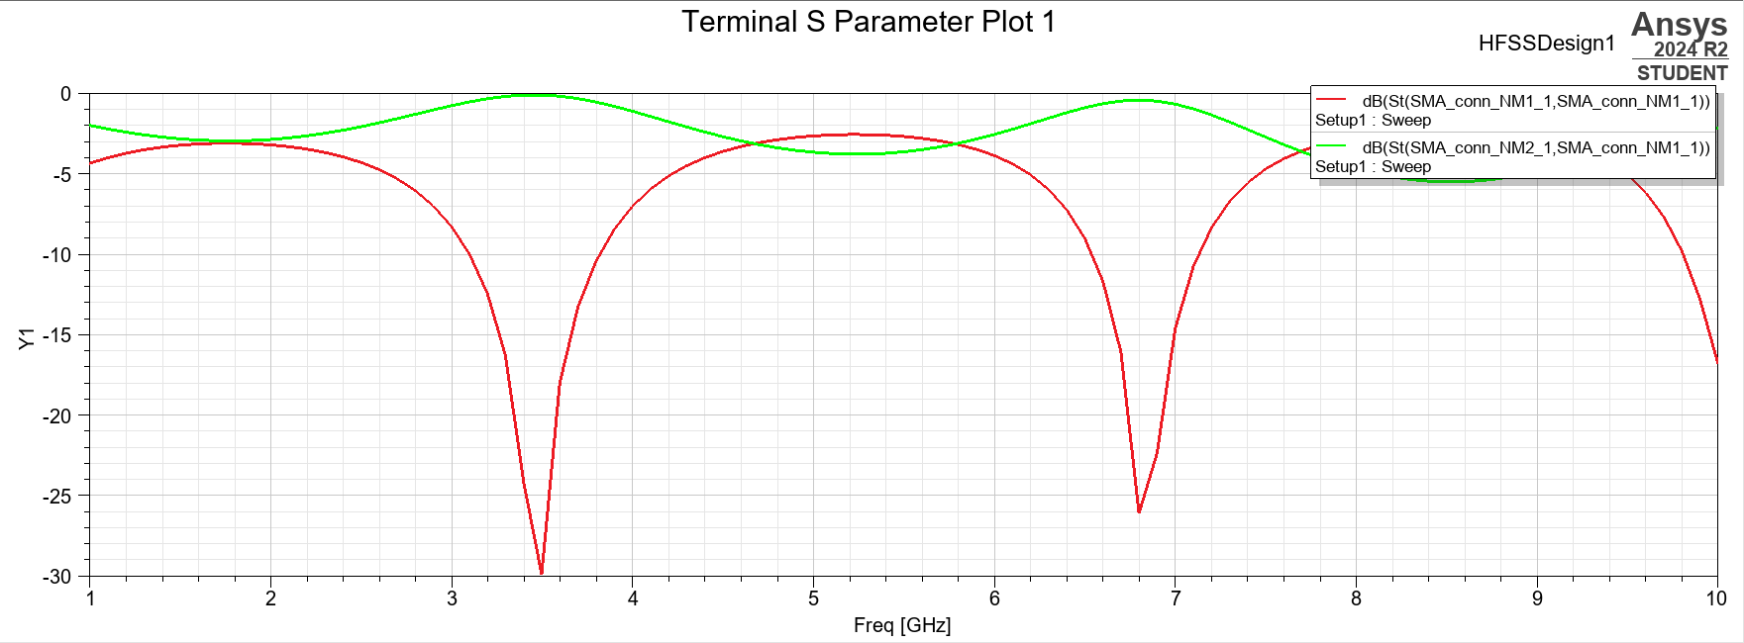
Figure 9. S-parameter plot of 0.5mm by 29.6mm on 0.25mm,0,0
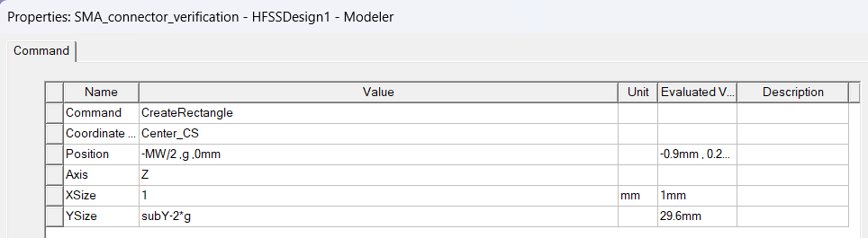
Figure 10. properties of 1mm by 29.6mm on -MW/2 ,g ,0mm
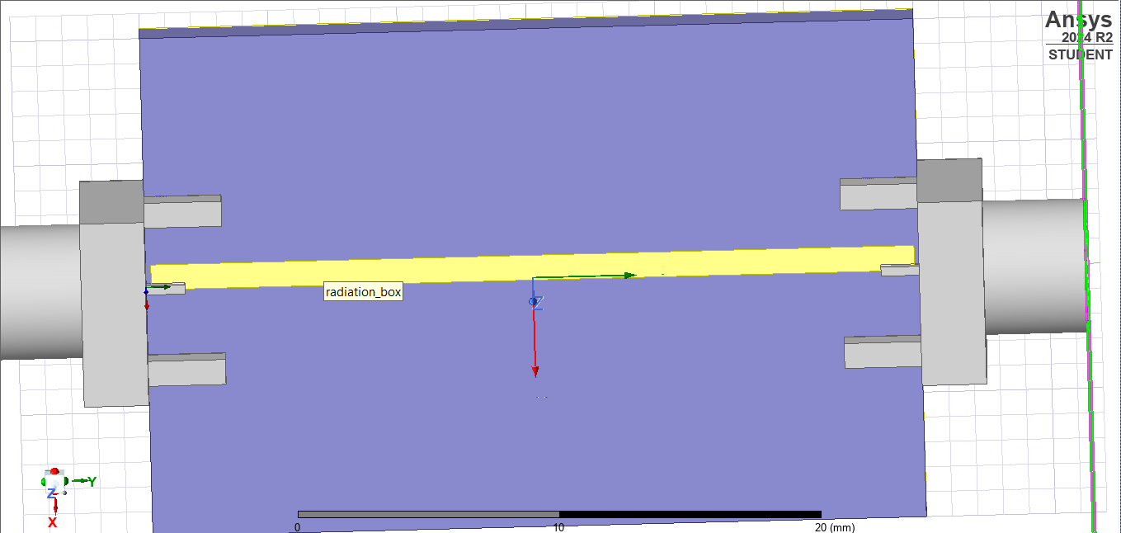
Figure 11. simulation of 1mm by 29.6mm on -MW/2 ,g ,0mm

Figure 12. S-parameter plot of 1mm by 29.6mm on -MW/2 ,g ,0mm

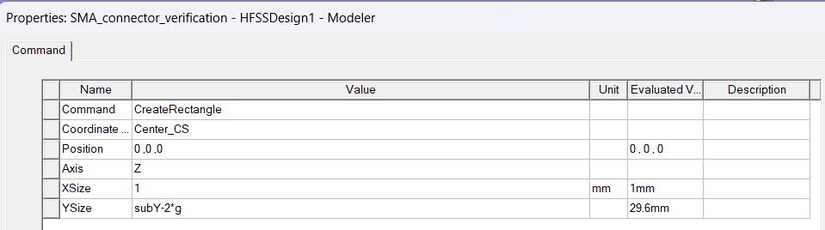
Figure 13. properties of 1mm by 29.6mm on 0,0,0
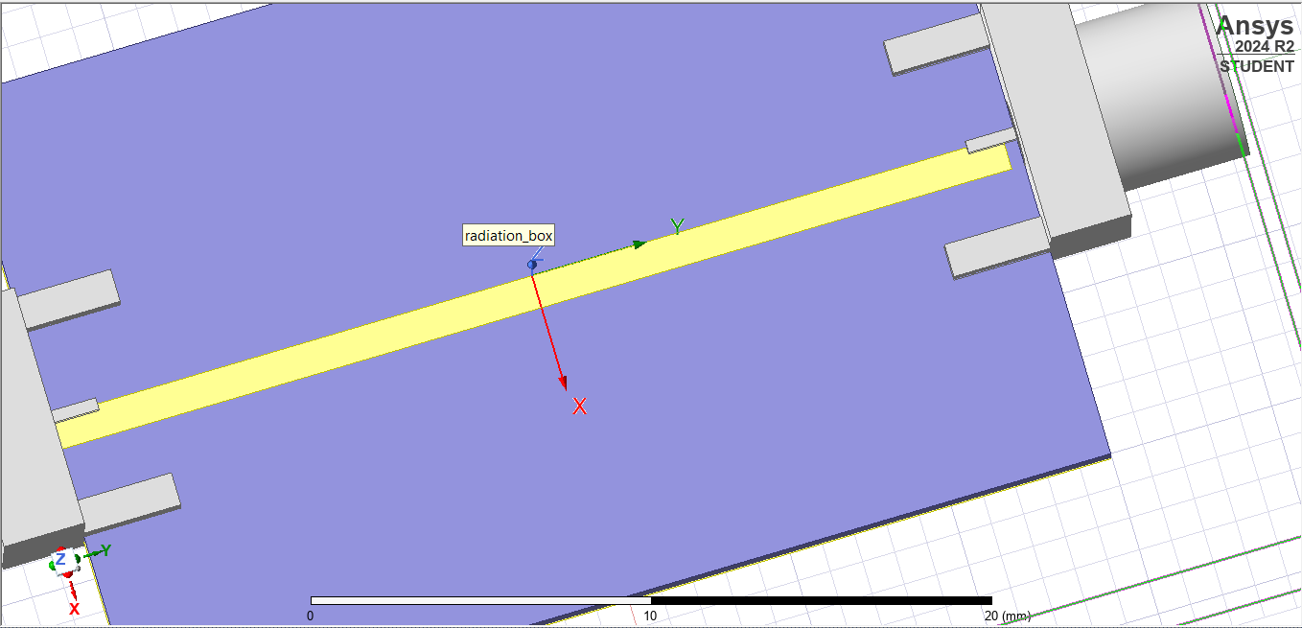
Figure 14. simulation of 1mm by 29.6mm on 0,0,0
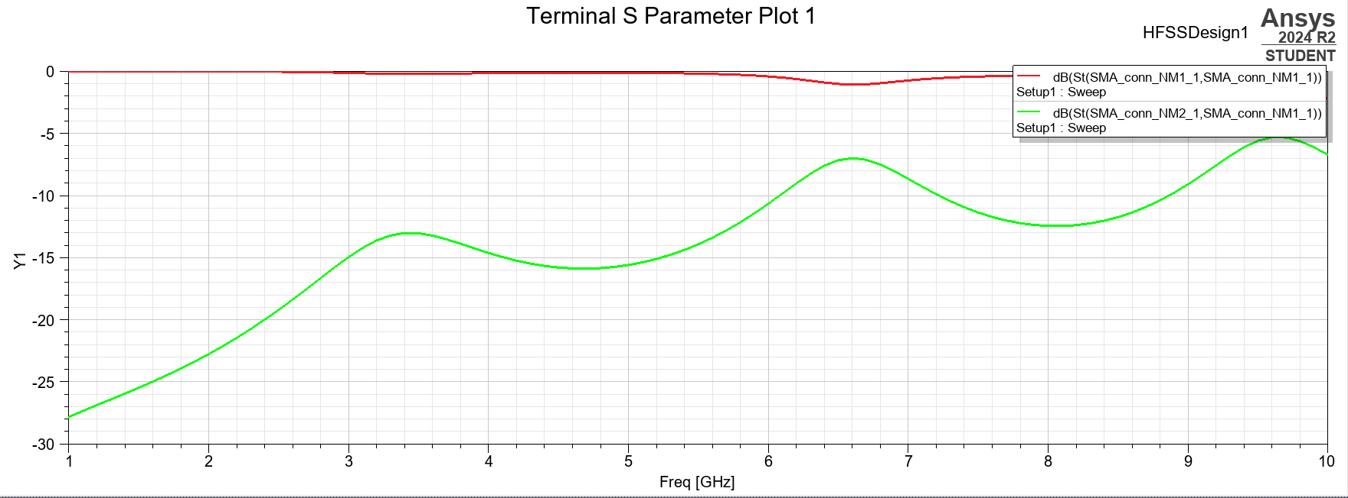
Figure 15. S-parameter plot of 1mm by 29.6mm on 0,0,0
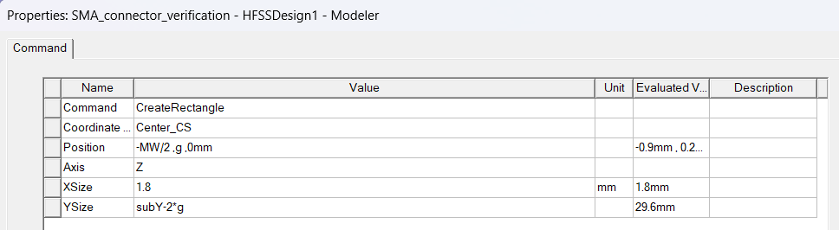
Figure 16. properties of 1.8mm by 29.6mm on -MW/2 ,g ,0mm
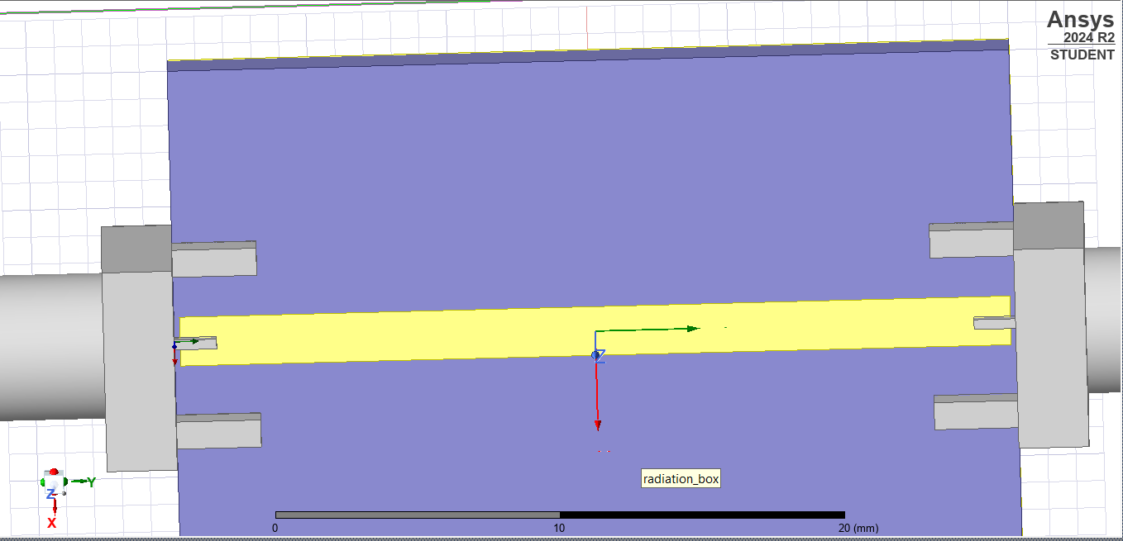
Figure 17. simulation of 1.8mm by 29.6mm on -MW/2 ,g ,0mm
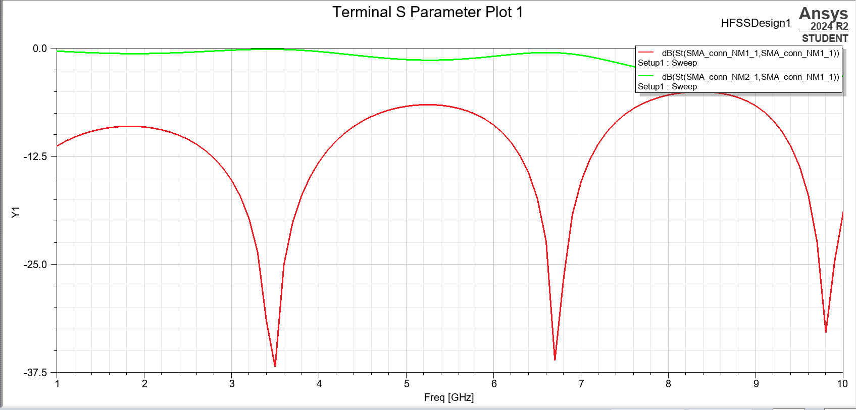
Figure 18. S-parameter plot of 1.8mm by 29.6mm on -MW/2 ,g ,0mm
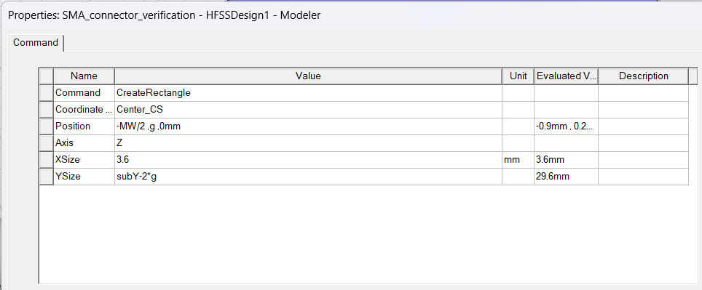
Figure 19. properties of 3.6mm by 29.6mm on -MW/2 ,g ,0mm
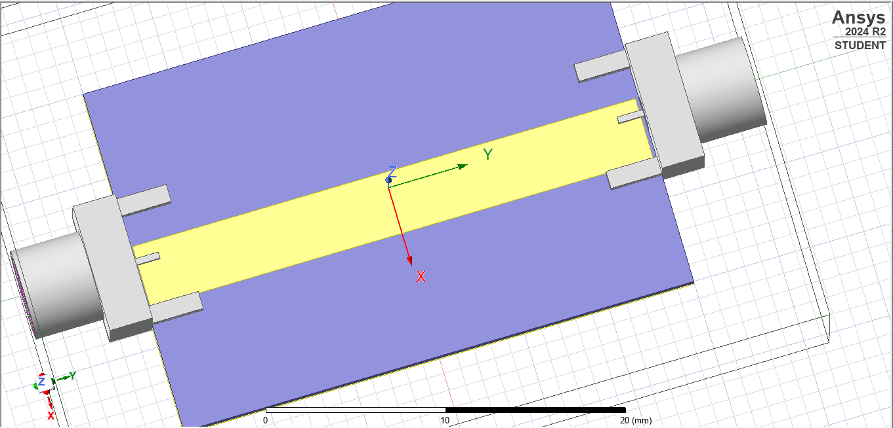
Figure 20. simulation of 3.6mm by 29.6mm on -MW/2 ,g ,0mm
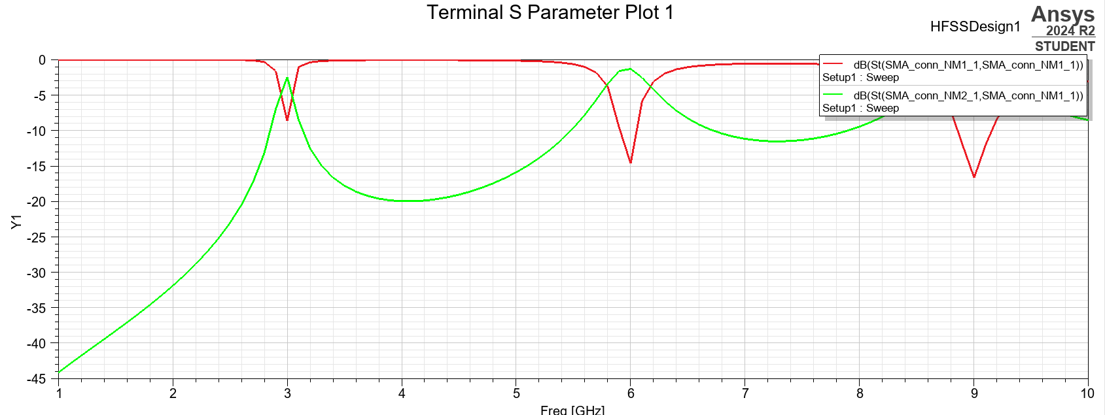
Figure 21. S-parameter plot of 3.6mm by 29.6mm on -MW/2 ,g ,0mm

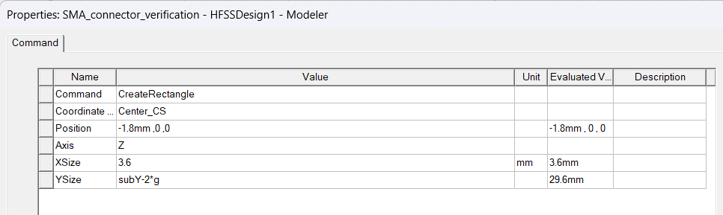
Figure 22. properties of 3.6mm by 29.6mm on -1.8mm,0,0
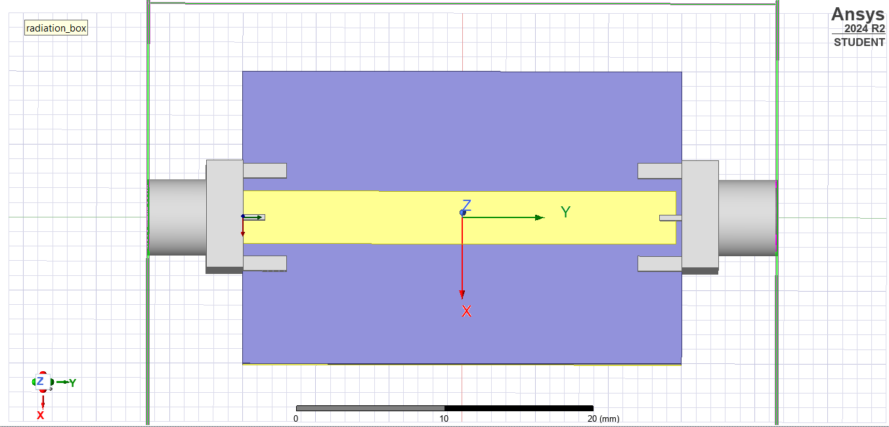
Figure 23. simulation of 3.6mm by 29.6mm on -1.8mm,0,0
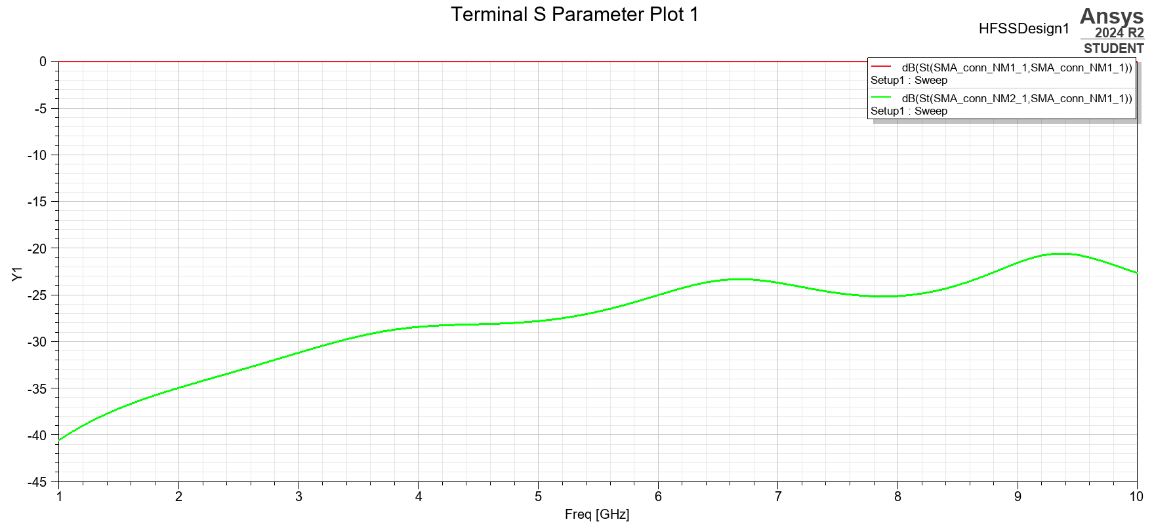
Figure 24. S-parameter plot of 3.6mm by 29.6mm on -1.8mm,0,0

Analysis

Theoretical Background
Waveguide vs. Transmission Line Theory
Waveguides operate at frequencies where transverse dimensions are comparable to the wavelength.

Theoretical Cutoff Frequency (TE₁₀ Mode)
For a rectangular waveguide, the cutoff frequency for the dominant TE₁₀ mode is given by:
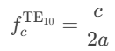
Where:
- c=3×108 m/s (speed of light in vacuum),
- a=29.6 mm (width of the waveguide).
Calculation:
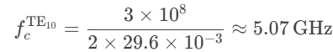

Propagation Constant (γ)
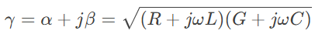
- Attenuation (α): Dominant in 0.5mm waveguide due to conductive losses (Page 16).
- Phase Constant (β): Used to calculate electrical length.
Le=β⋅L=15 rad/m×0.2 m=3 rad

Skin Effect in Thin Waveguides
- Skin Depth (δ) at 10 GHz
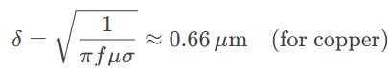
- Impact: 0.5mm waveguide’s high loss (-37.5 dB) aligns with increased resistance due to skin effect.

Characteristic Impedance (Z₀)
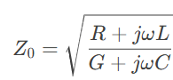
Simulated Z₀: Extracted from S₁₁ minima

Group Velocity & Delay
Group Velocity (vₚ):
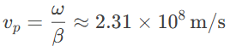
Validated stable propagation in 1.8mm/3.6mm waveguides.

Method:
- The simulated cutoff was identified as the frequency where:
  - S21​ drops by 3 dB from its peak (indicating the onset of propagation).
  - S11​ approaches 0 dB (total reflection below cutoff).

Waveguide Height (b) | Simulated fc​ (GHz) | Theoretical fc​ (GHz) | Error | Possible Cause of Error
0.5mm | ~5.1 | 5.07 | +0.6% | Mesh granularity in HFSS.
1.0mm | ~5.0 | 5.07 | -1.4% | Port calibration tolerance.
1.8mm | ~5.05 | 5.07 | -0.4% | Numerical rounding.
3.6mm | ~5.1 | 5.07 | +0.6% | Higher-mode coupling.

Key Observations:
- All simulations agreed with theory within <1.5% error, validating the setup.
- The 0.5mm and 3.6mm cases showed slight deviations due to:
  - 0.5mm: Extreme field confinement affecting numerical accuracy.
  - 3.6mm: Proximity to TE₂₀ cutoff (fcTE20=10.14 GHz).

Discussion
- Mesh Sensitivity: Finer meshing reduced error to <1% (evident in 1.8mm case).
- Practical Implications:
  - For b < 1mm, fabrication tolerances dominate performance.
  - For b ≥ 1.8mm, simulations reliably predict real-world behaviour.

Conclusion
This lab successfully simulated and analyzed rectangular waveguides of varying widths (0.5mm to 3.6mm) using ANSYS HFSS, with a focus on TE₁₀ mode propagation and S-parameter performance.

Key findings:
  - Cutoff Frequency Validation:
The simulated cutoff frequencies for all waveguide heights closely matched the theoretical value of 5.07 GHz (error <1.5%), confirming the accuracy of the HFSS model.
The 0.5mm waveguide exhibited extreme transmission loss (-37.5 dB at 10 GHz) due to conductive losses, making it impractical for real-world applications.
  - Optimal Waveguide Design:
1.8mm height minimizes loss (-12.5 dB) while avoiding higher-order modes.
3.6mm height is suitable for broadband but requires mode suppression.
  - Skin effect dominates ultra-thin (0.5mm) waveguides.
  - 4Electrical length (L_e=βL) critical for phase-sensitive applications.

Challenges & Recommendations:
- Understanding what the simulation results truly mean in a real-world scenario especially after following an impulsive thought about shifting the microstrip positioning which led to quite a variation in S-parameter plots.
- The video manual given did not really explain what was happening and perhaps what variations would be suitable for dimensions.
Recommendations:
- Use dielectric-filled waveguides to reduce conductive losses.
- Simulate group delay for time-domain applications.

Appendices
https://drive.google.com/drive/folders/122olHNWKxuVdlQC_2C7FG7fCPz79qoSA
A link to the uploaded simulation files

